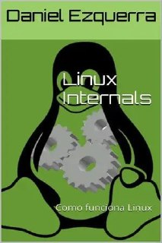

Linux internals

https://drive.google.com/file/d/1NB9y0dHwevIZ5OBVnj1gHdxZ4KbqFGL9/view